Quick Reports: End User Instructions

[***https://yourdomain.com/report-creator***](https://yourdomain.com/report-creator)

# 

# Running a Report

1. Select either the **New Quick Report** option from the home page or the **Quick Report Templates** from the top menu to begin your first report.
2. Click on the name of a report category (Bills, Circulations, Holds, Items, Patrons) to view the types of reports available in that category.
3. To learn more about each report, click on the **Description** link. This will open a pop-up window describing what information the report will produce, followed by a technical description of what the report will display and the report filters. Click the ‘X’ to close the pop-up window.
4. Click **Create a Report** to open the report template.
5. Type in a **Report Name** of your choice and fill in the **Choose Report Filters** options. It is a good idea to make the **Report Name** as descriptive as possible so that you may easily identify it in a list of reports. The **Report Filters** will be different for each template but will often ask you to choose which library/libraries the report is for (CTRL-Click to select multiple branches), and will often ask you for a date or range of dates. You may occasionally be asked for specific Circ Modifiers, Shelving Locations, Patron Permission Groups, etc.

*About Date Ranges:* If you are asked to enter a date range, enter the oldest date first. A “Real Date” is a calendar date such as “09/14/2015” and a “Relative Date” is a count of a number of days “7 days ago.” If you are setting up a recurring report, be sure to use relative dates (if you use real dates, it will run the report on the same set of dates each time it recurs).

1. Click **Run Report** to submit your report to the server to be processed.

# Other Report Template Options

* **Report Description:** This is an optional field that you can use to store information about the report for later reference (such as the person who asked you to run the report, the reason why you ran the report, why you chose the filter options you did). This information will not appear on the report output.
* **Report Output Options – Recurrence Interval:** If you just wish to run the report once, leave the default as **Run one time only**. If you wish the report to automatically run on a scheduled basis, change the option to **Recur every** and choose from the dropdown options for a number of days/weeks/months.
* **Report Output Options – Run Time:** If you wish to run the report immediately, leave the default as “As soon as possible.” If you wish to run it over night or on another day (particularly if you are scheduling a repeating report), then choose the **At a scheduled time on** options. If running system-intensive reports that take a significant amount of time (particularly weeding reports), it is a good idea to schedule them to run overnight.
* **Email Notification:** If your account profile has an email address associated with it, it will be automatically filled in. You may remove it, change it, or add multiple email addresses separated by commas. When the report is ready, the system will send an automated email notification with a link to the report results to any email address listed there. If you send the report to someone else using this function, the person receiving the message will need to have an account with the VIEW_REPORT_OUTPUT permission enabled in order to open the report results. If you need to send the report to someone else that does not have Evergreen reports permissions, then you can save the resulting Excel file to your local drive, and then attach it to an email to distribute.
* **Output Options:** To see this option, click **Show All Options**. By default, your report will be created in Excel (preferred by most users) and **HTML** (for viewing in the browser). Depending on your needs, you may also choose **CSV** (comma-separated values), and you may choose to have it create simple bar and/or line charts with the **HTML** output as well.
* **Pivot Label Column** and **Pivot Data Column**: To see these options, click **Show All Options**. Use these to change the layout of the resulting report output (for example, have the labels display on the side instead of the top).
* **Save as Draft:** If you begin filling out a report form and wish to stop and return later to finish filling it out, you may use the **Save as Draft** option. To complete it at a later time, click on the **My Draft Reports** menu option.

# Viewing Your Report Results

1. Click on **My Quick Reports** to see the list of your reports that you have already run, that are currently running, and that you have scheduled to run in the future.
2. Click on the **Category** of your report. The reports are organized in the same categories as the templates (Bills, Circulations, Holds, Items, Patrons).

*In the example shown below, the “Items Added in March” report is scheduled to be run and the following reports have completed.*

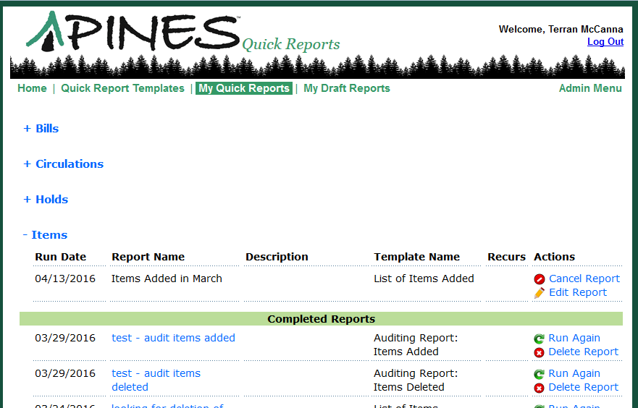

If a report is scheduled and has not yet been run, you have the option to **Cancel Report** or **Edit Report** (change options such as the email address to which you wish to send the notification).

If a report has already been run, you have the option to view the report (by clicking on the report title), to **Run Again** (this will allow you to change the selected filters and notification options), or to **Delete Report** (which removes it from your list).

1. View your completed report by clicking on the report title. A new browser tab will open and may prompt you for your Evergreen login name and password. After you log in, you will be presented with viewing options.

If you chose the default report output options, you will see a page with links to **Tabular Output** (HTML, viewed in the browser screen) and to **Excel Output**. Most people prefer to view the results in Excel because they are able to take advantage of Excel’s sorting and calculating functions to further organize data and create charts.

The one small issue with using Excel is that it does not know how to display long numbers such as barcodes properly, so you may see columns of data that say “5.07E+13” or similar. After you open the file in Excel, select the column of data that contains barcodes, right-click on it, and select Format Cells.

On the Number tab, change the Category to Number and the Decimal Places to 0. Click OK.